There are two folders here, one is for node and the other is for vue

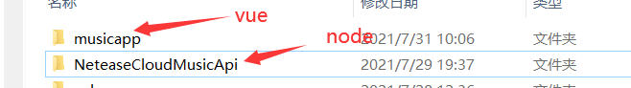

First Run these two programs

Node app.js and npm run serve

Then you will see this interface



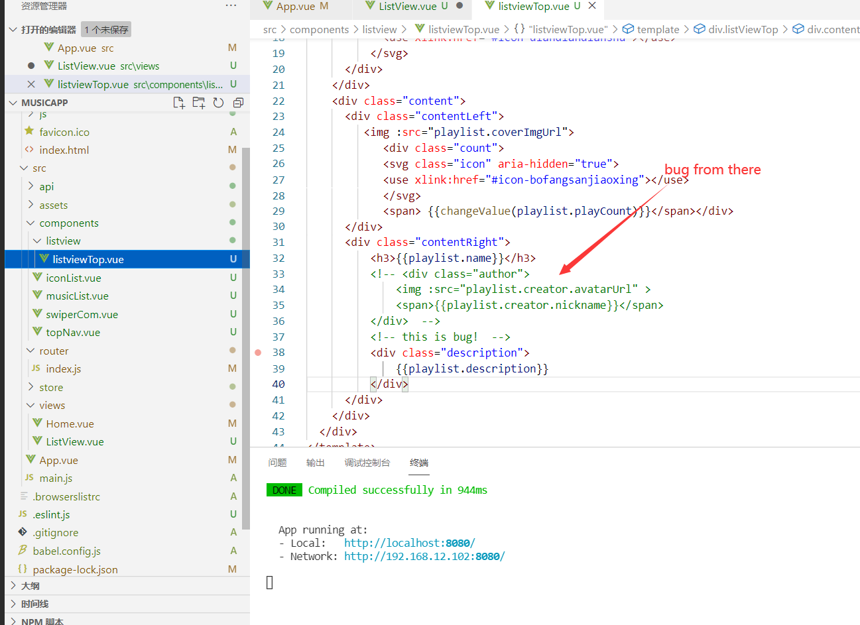

Open source

then you comment this locatio nand click on the picture

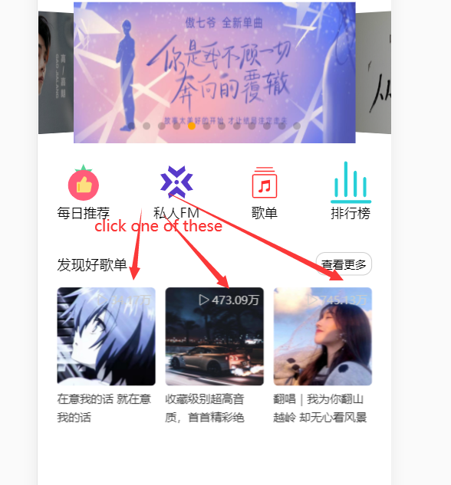

Then you will see this interface

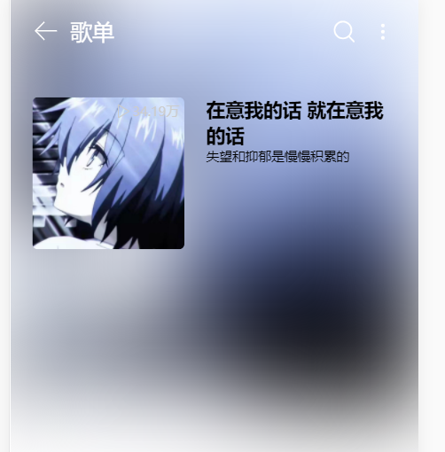

Then Uncomment,like this

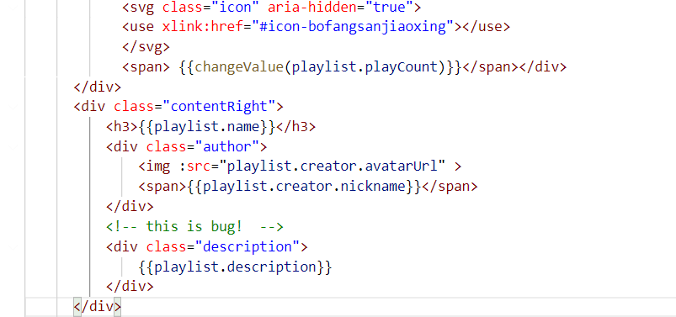

You will see

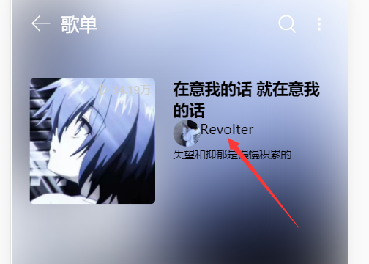

And you flush

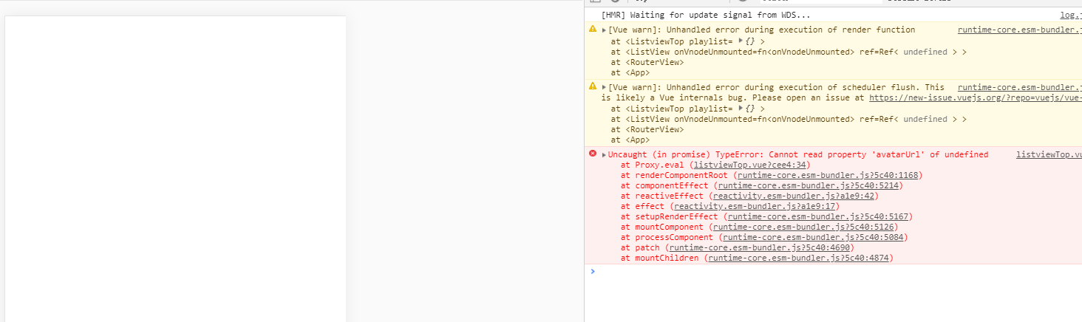

In fact, after commenting out this paragraph, no matter how many times it is refreshed, there will be no such result. I personally think that vue3 has not handled the process of continuously passing down an object.